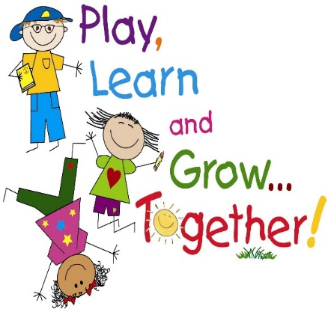
Baturyn
Community
Playschool

Kind Sir or Madame;

We hope that you will take a few moments to read about our upcoming event and decide to participate by donating to our auction personally or through your business.

Baturyn Community Playschool is a preschool that is different than most local or early education programs, in that we are a non-profit, parent cooperative. We provide a unique family focused preschool program for three to five year olds that is overseen by parent volunteers. As we are a non-profit organization, we require fundraising to support our program, keep costs affordable for local families and ensure that our school can continue to offer our progressive program.

Baturyn Playschool will be hosting a silent auction on December 10th and 11th, 2015 at Baturyn Community Hall. We anticipate approximately 200 guests to attend. Please consider supporting our event by donating a gift certificate, merchandise or service. In exchange you will receive some excellent community exposure and advertising. We will gladly pick up your donation in Edmonton, or it can be mailed to us at the address listed below. Please include extra business cards for us to distribute.

Auction items can include the following:
-Items: Such as collectibles, jewelry, logo items and tickets, scrapbooking supplies, kitchen items, pamper your pet, handbags, the popular toy(s) for the holidays, liquor etc.
-Gift certificates: Restaurants, entertainment tickets for movies, sports, concerts, museums, memberships, golf, beauty salons, travel, furniture, electronics, and computers, etc.
-Baskets: Turn in a completed basket by including items/certificates, and or services around a theme like Holidays, Fine Foods, Family Night Out, Family Game Night, reading, Spa Getaway, Sporting Basket, Camping Gear, Just for Girls, Just for Boys, Emerging Artist, Fun in the Sun, Etc.
-Services: Spa treatments, birthday parties, medical and dental treatments, art lessons, babysitting, private sports lessons, lawn services, etc.

Stephanie Plamondon
(780)-266-9670
Email: bcps.Fundraiser@gmail.com

